**CDWeb - Retrieve Gas Choice Number When Account Number is Known**

**CDWeb Access**

To obtain a User Name and Password to the CDWeb, please complete the *Customer Consumption Data (CDWeb) Reporting Agreement*. The Agreement can be found on BGE’s Energy Supplier website, <http://supplier.bge.com/documents/Consumption_Data_Agreement.pdf> or active gas suppliers having DSWeb access can find the *Customer Consumption Data (CDWeb) Reporting Agreement* on the DSWeb in the Main Library under Applications and Forms.

The CDWeb (Consumption Data Web application) provides the gas supplier the ability to look-up a Gas Choice ID number when only the Account number is known. The Gas Choice ID must be used when submitting a request for historic usage.

The following information is designed to help you navigate through CDWeb to retrieve the Gas Choice number.

Log into the CDWeb:

* CDWeb website - <https://cdweb.bge.com/cdweb>

OR

* Go to BGE’s Supplier Website at <http://supplier.bge.com>
* Select the ***CDWeb*** Tab located at the top right corner. You may also select the ***CDWeb*** application from the Menu at the bottom of the screen.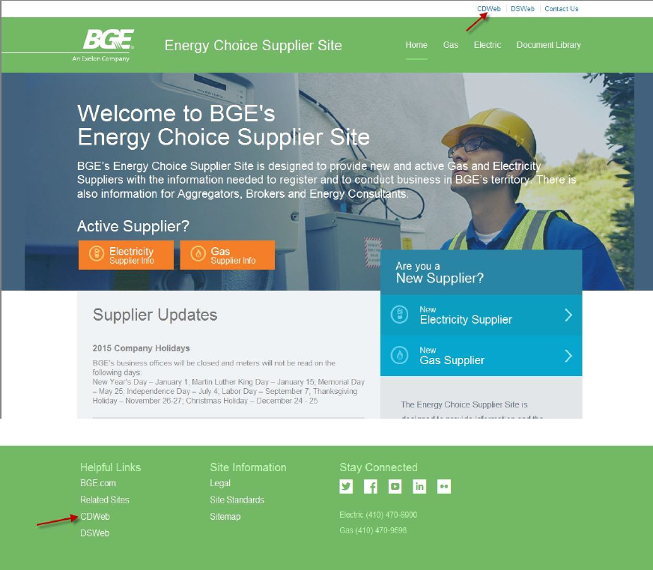

Input ***User Name*** and ***Password*** (case sensitive) on the BGE Login screen

Click the ***Yes, I understand and agree to the terms and conditions I have read in the link provided below*** box after reading the Terms and Conditions

Click ***Submit***

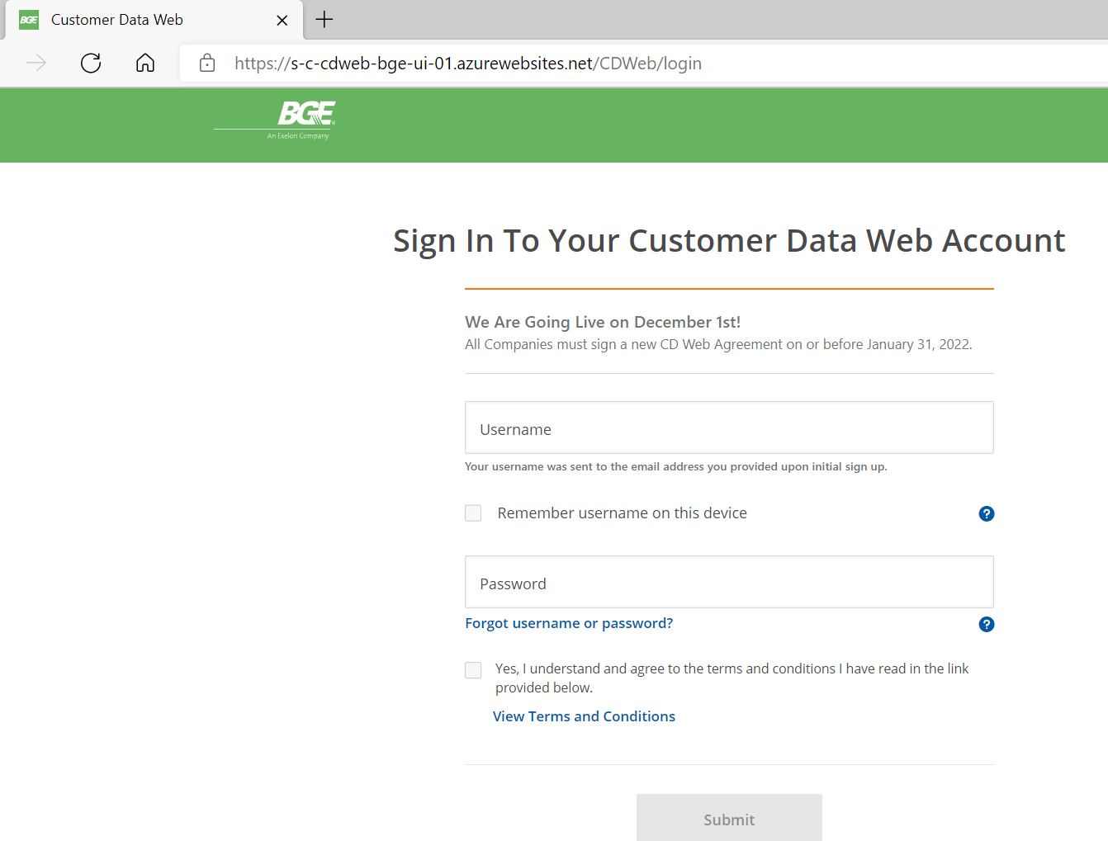

Select ***Request Data***

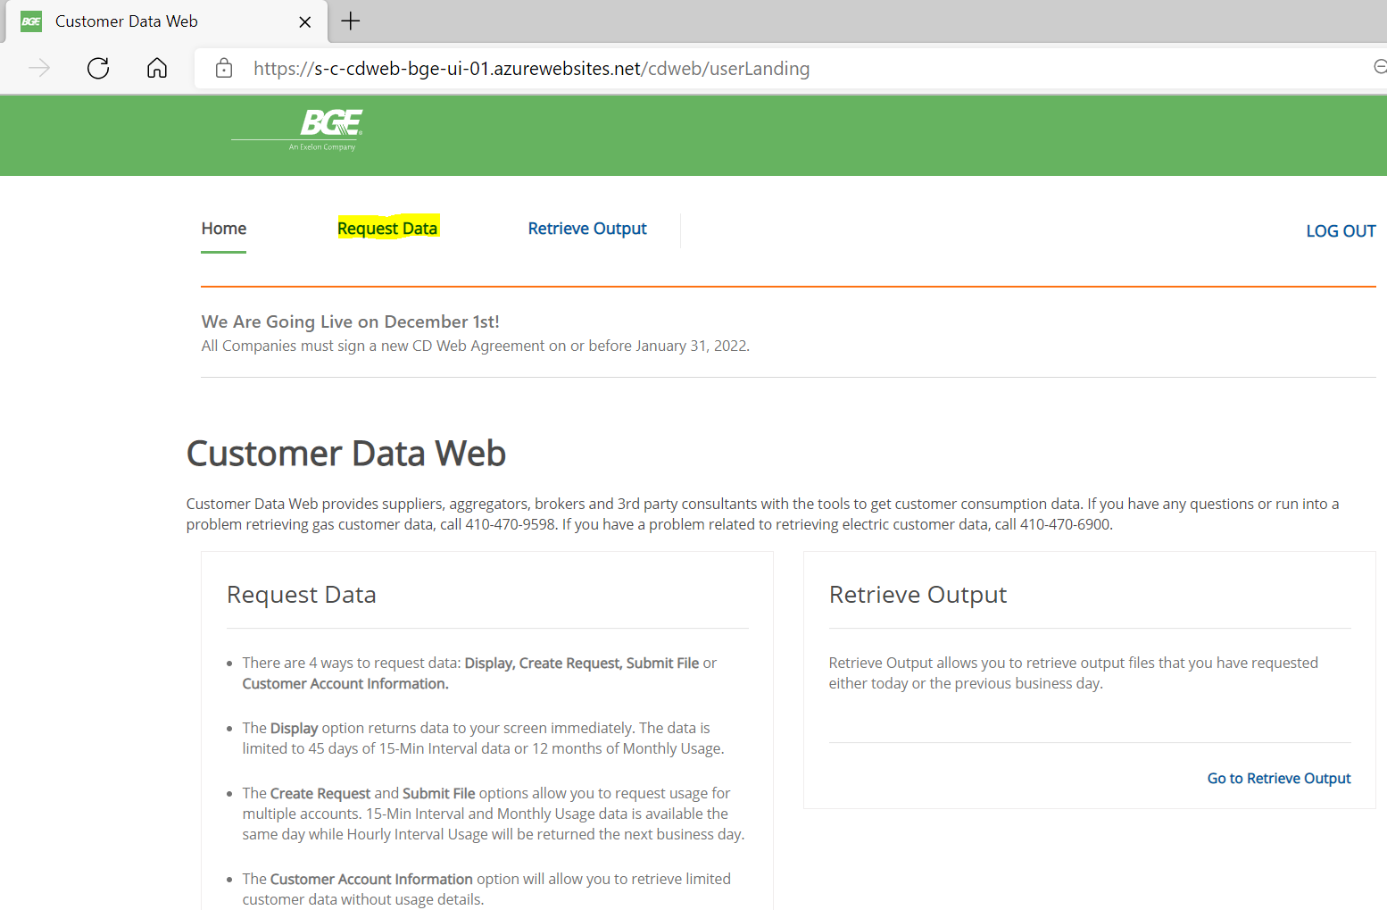

Select ***Customer Account Information***

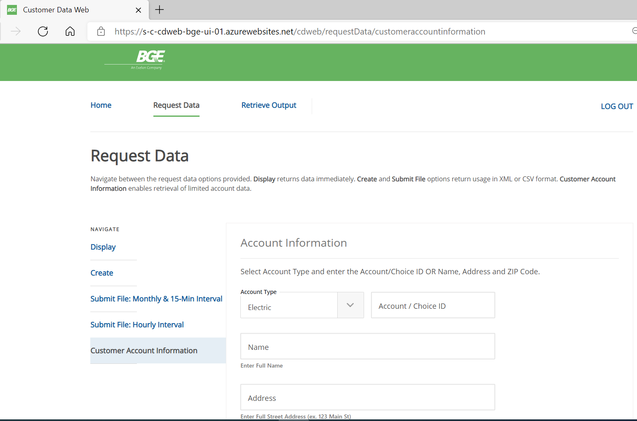

Select Gas in the ***Account Type*** dropdown and Enter the Account ID in the ***Account/Choice ID*** field.

Click ***Submit Request***

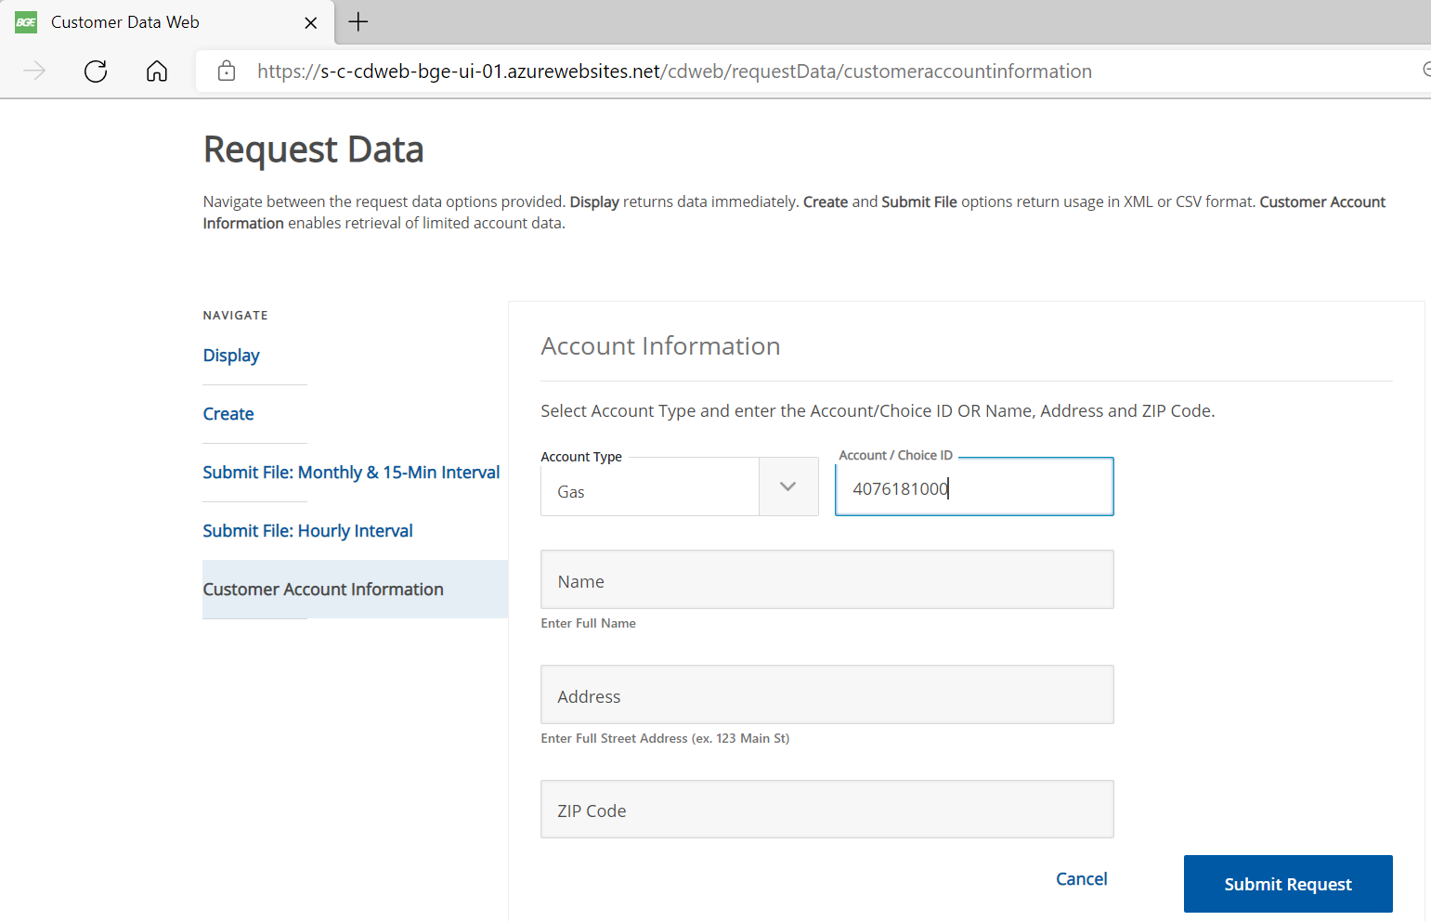

The Account ID, Gas Choice ID, Account Type, Name Address and Zip is displayed.

