**CDWeb -View Customer’s BGE Bill**

**CDWeb Access**

To obtain a User Name and Password to the CDWeb, please complete the *Customer Consumption Data (CDWeb) Reporting Agreement*. The Agreement can be found on BGE’s Energy Supplier website, <http://supplier.bge.com/documents/Consumption_Data_Agreement.pdf> or active gas suppliers having DSWeb access can find the *Customer Consumption Data (CDWeb) Reporting Agreement* on the DSWeb in the Main Library under Applications and Forms.

The CDWeb (Consumption Data Web application) provides gas and electric suppliers the ability to access and view their customer’s BGE bill. The Gas Choice Number must be used to retrieve the bill.

**Retrieving the Customer’s BGE Bill**

The following information is designed to help you navigate through CDWeb to retrieve the Customer’s BGE bill.

Log into the CDWeb Website:

* CDWeb website - <https://cdweb.bge.com/cdweb>

OR

* Go to BGE’s Supplier Website at <http://supplier.bge.com>
* Select the ***CDWeb*** Tab located at the top right corner. You may also select the ***CDWeb*** application from the Menu at the bottom of the screen.

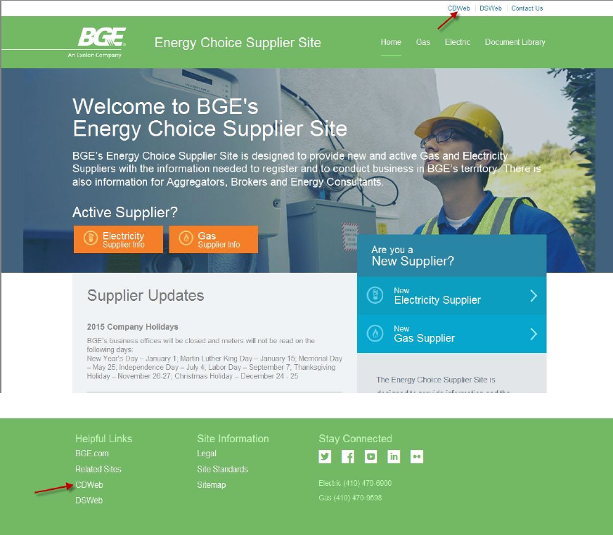

Enter ***Username*** and ***Password*** (case sensitive) on the BGE Login screen

Click the ***Yes, I understand and agree to the terms and conditions I have read in the link provided below.*** Checkbox after viewing the Terms and Conditions

Click ***Submit***

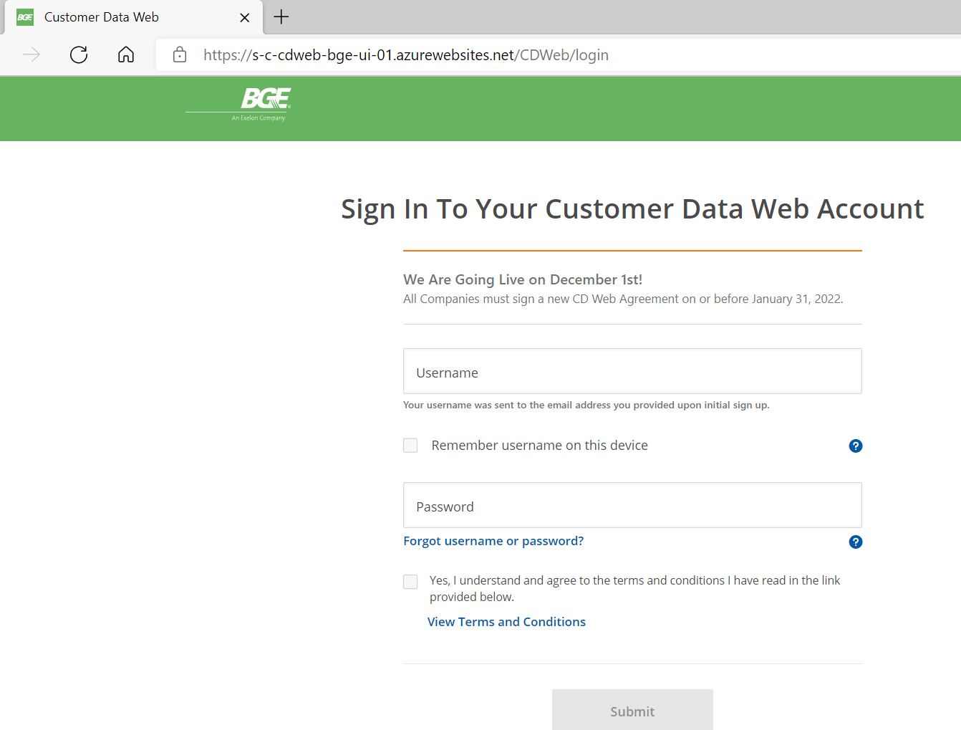

Select ***Request Data***

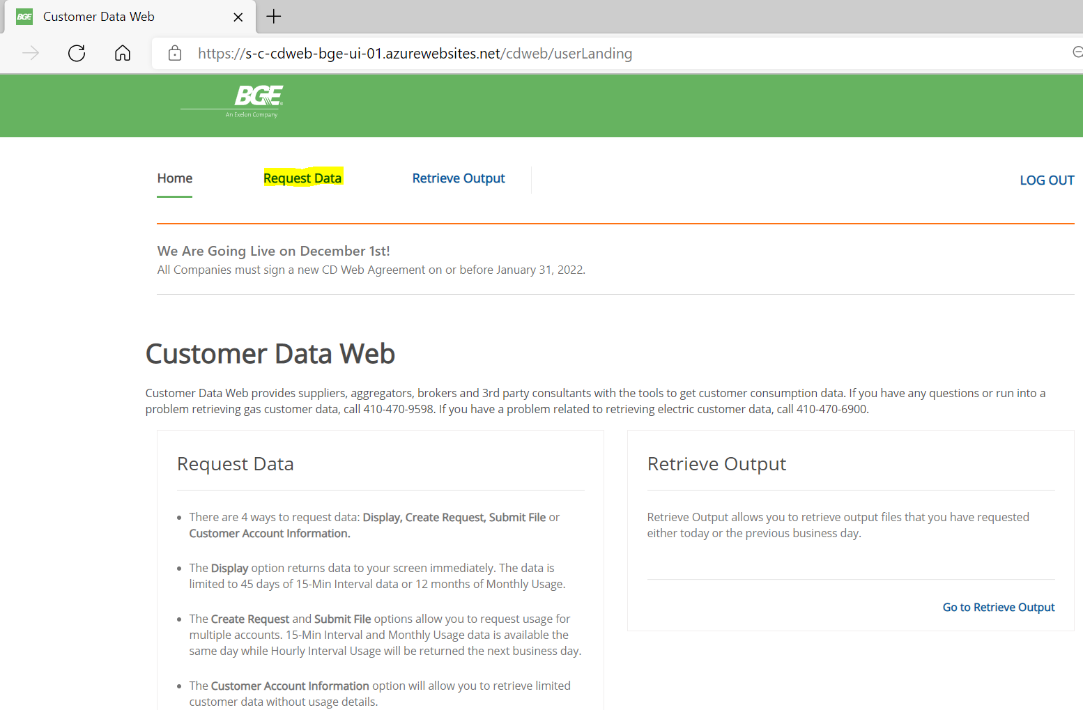

Select ***Display***

Enter the customer’s ***10-digit Gas Choice Number*** in the ***Choice ID*** field

Click the ***Monthly Usage All Accounts*** radio button

Select the ***Account Type*** of ***Gas w/bill***

Click ***Submit Request***

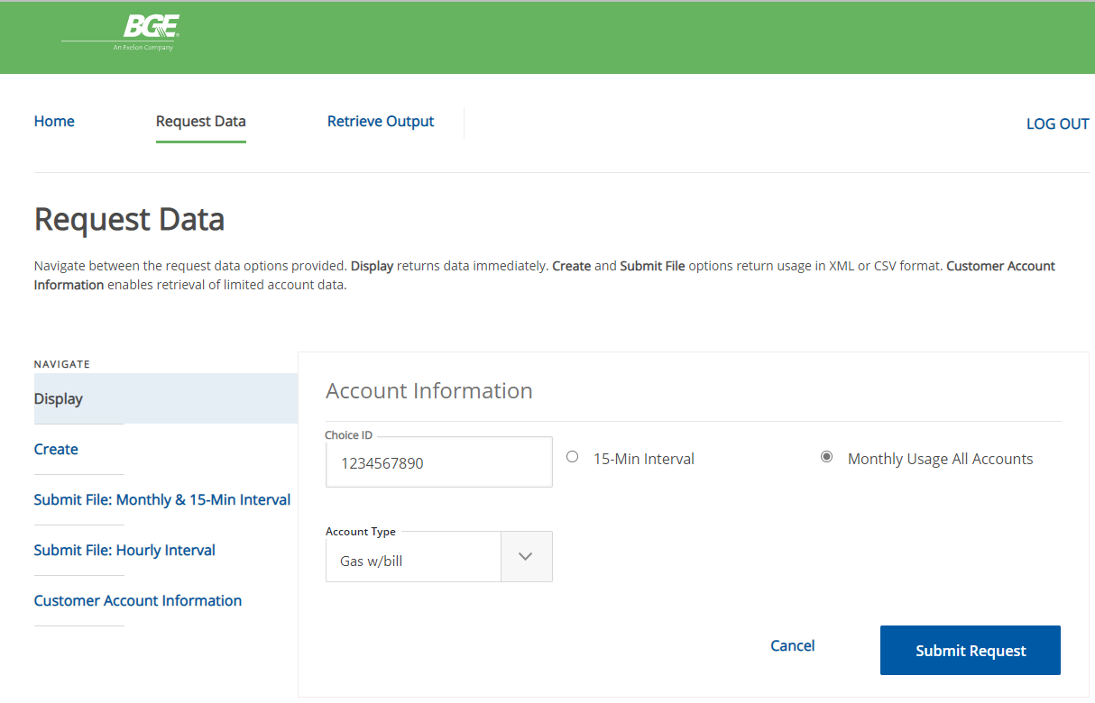

The Monthly Usage – Gas screen is returned with Current Bills

Select the ***View Bill*** link for the bill to be viewed

The selected bill will be displayed

