CDWeb – Retrieve Historical Usage using Name and Address
CDWeb Access
To obtain a User Name and Password to the CDWeb, please complete the Customer Consumption Data (CDWeb) Reporting Agreement. The Agreement can be found on BGE’s Energy Supplier website, http://supplier.bge.com/documents/Consumption_Data_Agreement.pdf or active gas suppliers having DSWeb access can find the Customer Consumption Data (CDWeb) Reporting Agreement on the DSWeb in the Main Library under Applications and Forms.

XML File Format
The CDWeb (Consumption Data Web application) provides gas and electric suppliers the ability to access BGE’s customers consumption data. Historical usage can be retrieved by using the Gas Choice Number or by using the customer’s name and address.
The request for historical usage must be submitted in a XML file format which requires a XML Editor such as XML Notepad. XML Notepad is a free application which can be downloaded from the Internet.
The schema format for the CONSUMPTION_RQST.xml can be found on BGE’s Energy Supplier website, http://supplier.bge.com/documents/XML_Schemas.zip.
The XML format for retrieving historical usage using Customer Name and Address is shown below. The fields in red font are required fields. The name and address must be entered exactly as displayed on the customer’s BGE bill and/or as shown on the Residential Customer List (BGE makes available an annual Residential Customer List for suppliers to purchase). The Name/Address search will not produce any data if the name or address doesn’t match the BGE bill/Customer List EXACTLY. The City and State should not be included in the XML transaction.

<CONSUMPTION_RQST>
<GasHistoricalAccounts>
<Account>
<AccountNumber/>
<AccountName>John Doe Smith Jr</AccountName>
<ServiceAddress>123 Anyway St *Apt 123, 21236</ServiceAddress>
<UtilityName>BGE</UtilityName>
<SupplierName>Gas Supplier Name</SupplierName>
<Commodity>GAS</Commodity>
</Account>
</GasHistoricalAccounts>
</CONSUMPTION_RQST>

- The only acceptable format to request historical gas usage is XML.

- Up to 250 accounts can be requested on one XML file. Each account requested must follow the same format as shown above.

- There is no limit to the number of files that you can send per day.
The following information is designed to help you navigate through CDWeb to retrieve historical usage when only the customer’s name and address are known.
Retrieve Historical Usage Using Customer Name and Address
Log into CDWeb:
- CDWeb website - https://cdweb.bge.com/cdweb
OR
- Go to BGE’s Supplier Website at http://supplier.bge.com
- Select the CDWeb Tab located at the top right corner. You may also select the CDWeb application from the Menu at the bottom of the screen.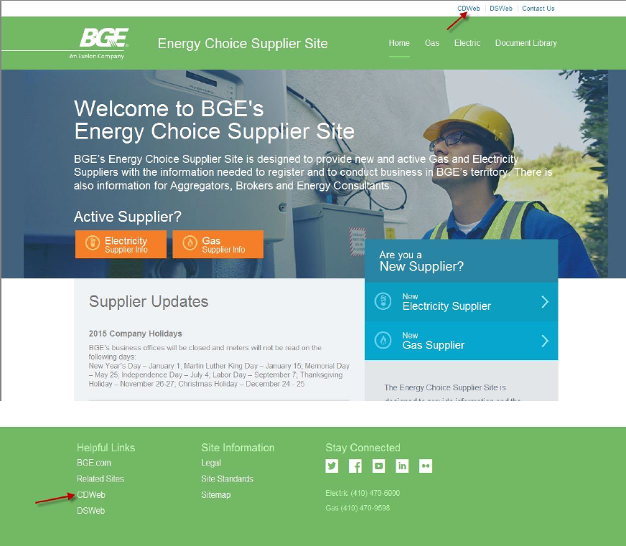

Enter User Name and Password (case sensitive) on the BGE Login screen
Click Continue
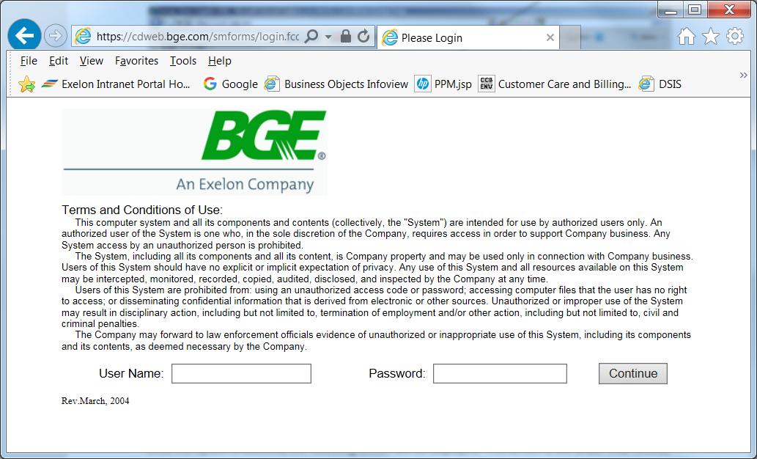

Select Initiate Request
Check the box for Request Confirmation
Select the Request Type of Submit Request File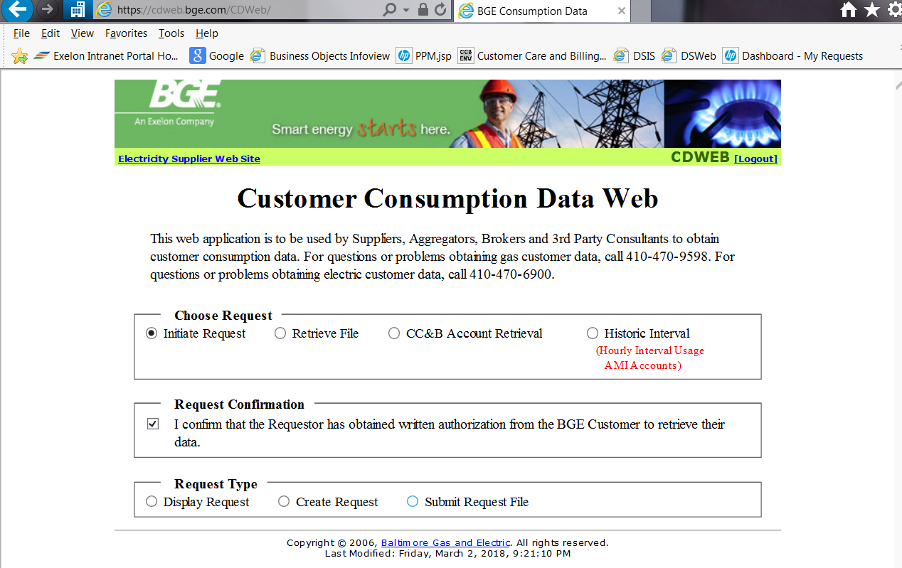
Select XML as the Output File Type
Enter your Email Address and select the Add Email button
Select the Browse… option and retrieve your XML file
Select Submit Request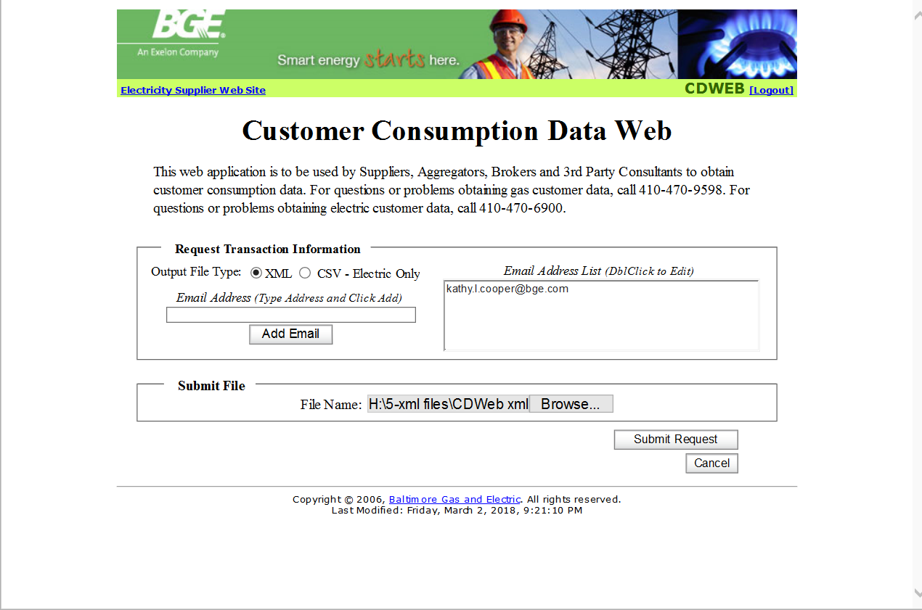

A CDWeb confirmation message will be returned with a reference number. 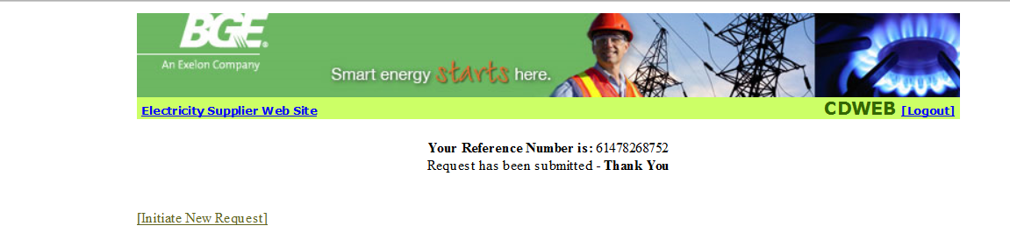

A confirmation e-mail is sent once the process has completed. Depending on the number of accounts in the CONSUMPTION_RQST file will determine how long the process will take. The response file stays in CDWeb for one day. If the Response is not retrieved within one day, a new CONSUMPTION_RQST must be submitted. 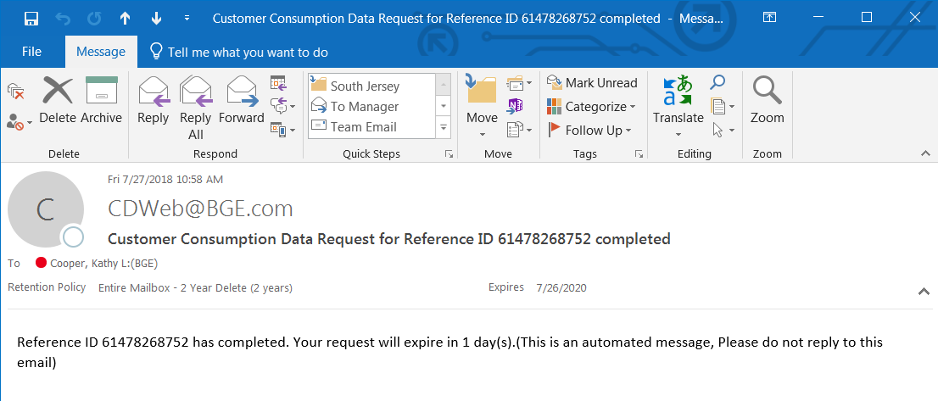

To view or download the CONSUMPTION_RESP file, select the option to Retrieve File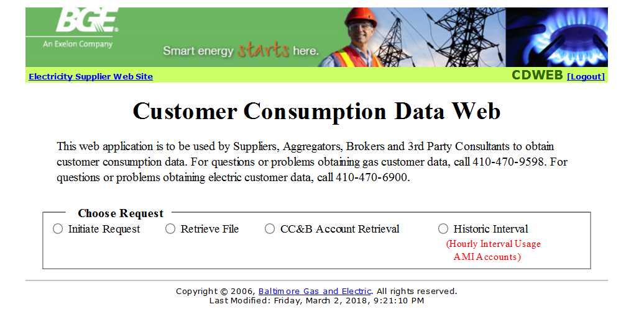

Select the option to Export to view or download the file. 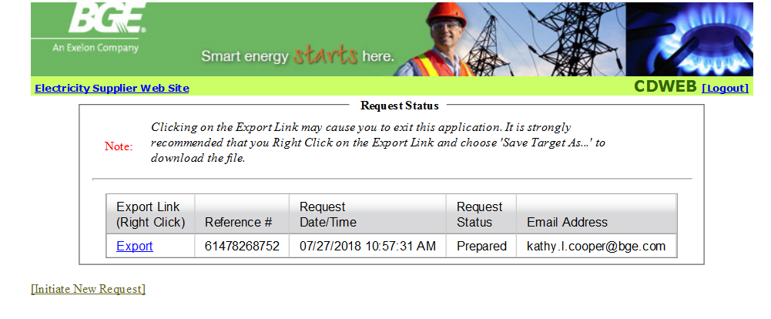

The CONSUMPTION_RESP displays the customer’s gas choice number, name, address, bill group, tariff code and up to 12 months of consumption data.
